**Task 1**

For this particular assignment, we are using the website owned and maintained by the city of Minnetonka, which is located and situated in the State of Minnesota US.

**Background and problem statement Minnetonka**

The city sits within the state of Minnesota, west of Minneapolis. It has a geographical land measurement of 73.29 square meters and a population of about 53,025 persons. Every quarter of the year, the Government of Minnetonka sits and evaluates its financial yearly performance, the goals of the next year and which projects to fund. The city government depends on funding from the Federal government and donation from other organisations to improve facilities within the city.

Apart from that, funding is also dependent on the taxes and collections that the city council collects from the residents daily. All these funds precipitate are used in the current and recurrent expenditure, some also go into developing new projects or purchasing new facility. As such the city management, came up with an open method of reporting how these funds are used and the progress of each project that the city has set aside funds for. Part of the accountability process included developing a BI reporting dashboard that is publicly available and vetable. This is the public dashboard that will be discussed in this task:

<https://performance.envisio.com/dashboard/city-of-minnetonka916/Goal-6721>

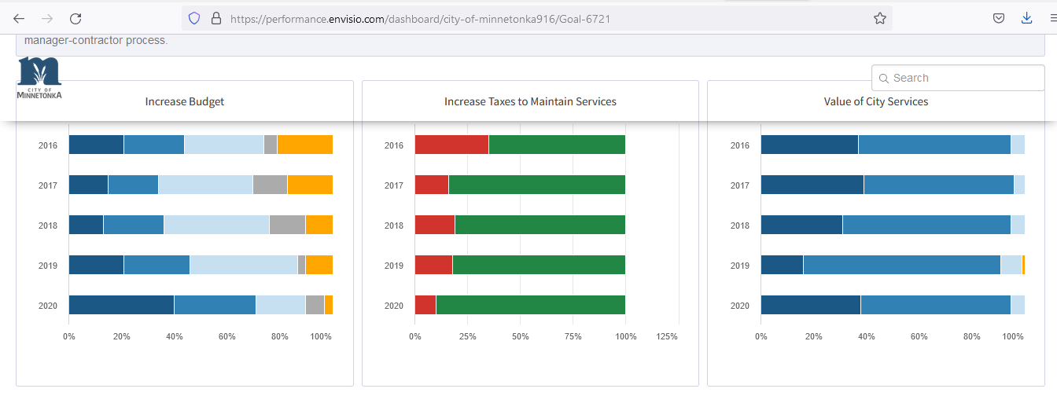

A.)

The following business decisions can be made from this data:

1. That across the years of 2016 -2020, the city voted in favour to increase taxes, so in order to increase services improvement to the people , taxations must be increased
2. That service provision to the people should continue going upwards since at stands, most residents have voted as being satisfied with the current service provision to the residents
3. There is need to continue providing services to the people and the community, since most of the activities focusing none this activity are not yet complete.

B.)

The following are some of the questions that would be asked based on this data:

1. How was the data used in this reporting collected?
2. From what sources were these data collected?
3. What is the structure of the data-set?

C.)

The following are some of the improvement points for this report:

1. Publicly available the data that was used in this analysis and even late on. This is important for researchers and other aspiring analysts
2. More analytical graphs and charts are supposed to be used, interactive numbers should also be added in tandem
3. The design and layout of the web page should also be improved, we can add nice layout with the different KPIs well aligned
4. A KPI navigation bar, whether on the left or at the top should be included to able smooth user interactions

**Task 2**

This report was created from a ready data source in CSV (attached in the assignment), combining of loan data of clients. The data is attached and has the following column values i.e. client id, date of loan, loan amount, location, currency, credit score and loan distribution status. Using power BI and similar replication done on Microsoft Excel. The report visualisation combined a variable measure of loan amounts, date of loan and location of loanees. A Pivot table was also generated for the same.

**Excel pivot table:**

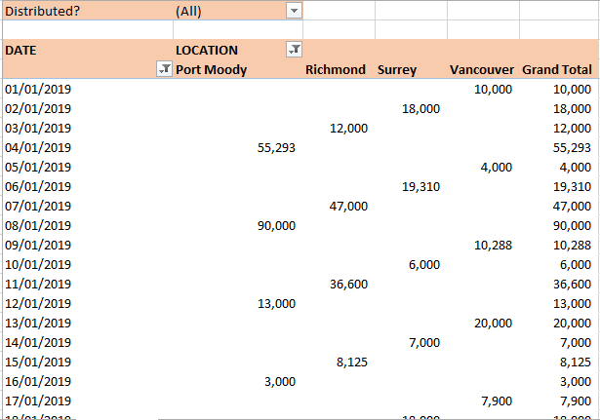

**Power BI reporting:**

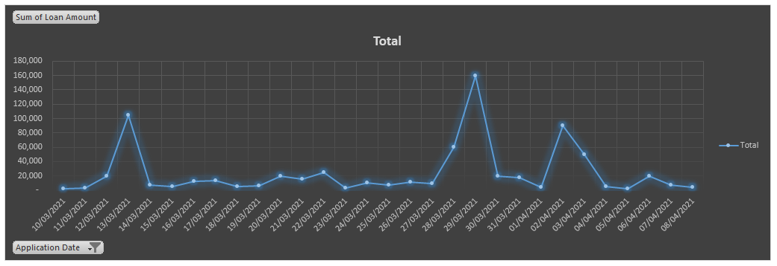

**REFERENCES**

Lachev, T., & Price, E. (2018). Applied Microsoft Power BI Bring your data to life!. Prologika Press.

Ehrenmueller-Jensen, M. (2020). Creating Columns from Examples. In Self-Service AI with Power BI Desktop (pp. 181-211). Apress, Berkeley, CA.

<https://performance.envisio.com/dashboard/city-of-minnetonka916/Goal-6721>